User Adoption Analysis

# Overview

The goal of this analytics project is to identify ‘adopted users’ and discover key factors that drive user adoption. The metric to identify user adoption is to calculate users who has logged into the product on three separate days in at least one seven-day period.

With **12,000 unique users**, **1447 became adopted users**, which is approximately **12.05% of total users**. Remaining users can be categorised into 2 broad categories namely – **Not Visited** (users who have never visited at least once after signup) and **Visited but not adopted** (Users who are not adopted users).

To find which features that would help increase user adoption are **last session creation time**, **year of account creation**, **organization ID**, **invited user id, creation source, email domain.** However, when the time of user account creation, we will not be able to use features like last session creation time.

The dataset used to identify feature importance was biased and highly imbalanced for negative class i.e., we have more non-adopted users than adopted users. I am using **CatBoost** algorithm for ML Modelling to predict/identify features that are helpful in finding adopted users. Also, due to its **Explainability** and **Interpretability**, I have used CatBoost. Other algorithms that can be used are XGBoost. AutoML solutions like PyCaret can also be used. The evaluation metric is set to be **AUC** rather than accuracy due to imbalanced data set use case.

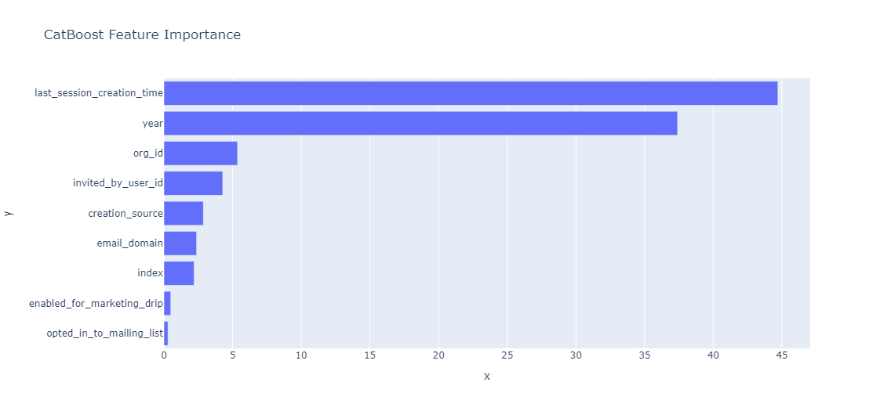

## SHAP values

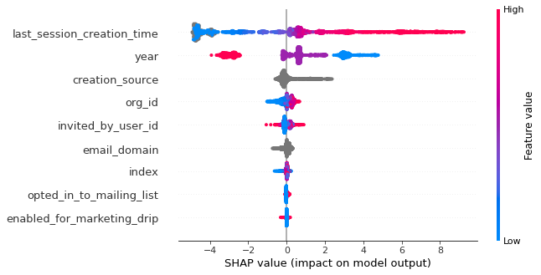

# Insights

* Most users have signed up using 6 major email domains, namely cuvox.de, gmail.com, yahoo.com, hotmail.com, jourrapide.com, and gustr.com.

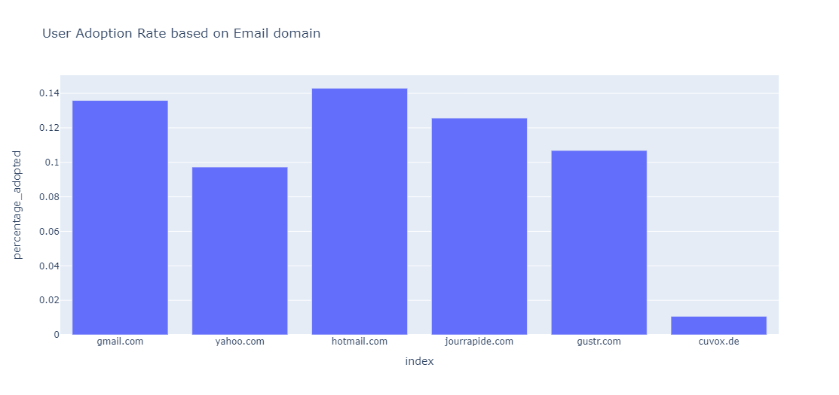

* Looking at numbers of percentage of adoption, users signing up through **Google Authentication** and **Guest Invite** tend to be using the application comparatively more.
* Also, interestingly we have a huge number of users who are organizational invites. But very less user adoption among them. Enhancing their user-experience will increase user adoption significantly.

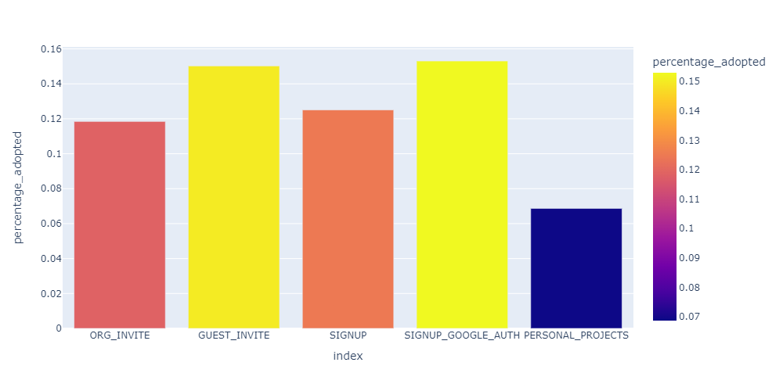

* Year-On-Year User growth analysis has shown that there is a **71.4% decrease in user adoption** and **37.9 % decrease in user signup** in the financial year **2014**, in comparison with 2013.

